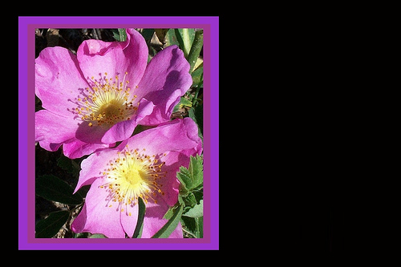

***Dear (Customer or Client Name),***

*Wishing you the happiness of following your heart, the comfort of loving those you care for, and the peace of discovering your special place in this world. May these gifts be yours today and every day.*

***Happy Birthday***

***Best Regards,***

**(Your Company Name)**