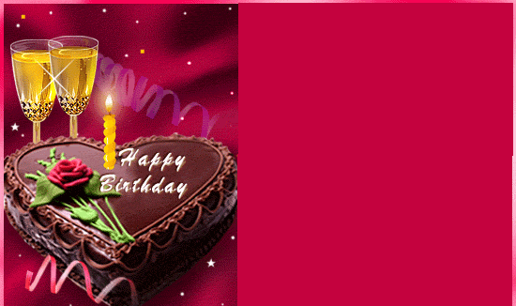

***Dear (Partner’s Name)***

*Even when the whole world is rushing, there are some who take time to mentor, encourage & inspire like YOU. And I’m extremely lucky to be working with someone like you.*

***Happy Birthday***

***Your Business Partner***

**(Your Name)**