Daughter to Mother Poems
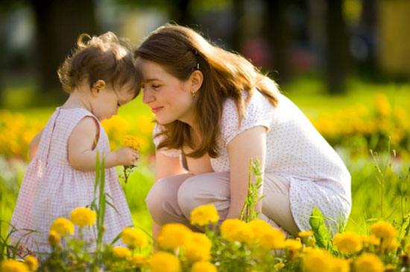
Mom
Long ago when I was small and everything was new,
I hoped and dreamed when I grew up that I'd be just like you.
Through the years you've helped me grow with love and strength to spare,
your guidance means so much to me that nothing could compare.
As you hold this hankie while I’m walking down the aisle,
my eyes will meet with yours and we’ll share a knowing smile.
For we both know my life will change on this my wedding day,
and all you’ve shared and taught to me will help me find my way.
Thank you Mom for Everything

Mom

Long ago when I was small and everything was new,
I hoped and dreamed when I grew up that I'd be just like you.

Through the years you've helped me grow with love and strength to spare,
your guidance means so much to me that nothing could compare.

As you hold this hankie while I’m walking down the aisle,
my eyes will meet with yours and we’ll share a knowing smile.

For we both know my life will change on this my wedding day,
and all you’ve shared and taught to me will help me find my way.

Thank you Mom for Everything

Thank You Mom
I realize as I marry
What it takes to be a wife,
it takes the things you taught to me all throughout my life.

It’s believing in another’s dream until it has come true,
cheering in the background, “I am so proud of you!”

It’s having your convictions and admitting when you're wrong,
it’s showing you have weaknesses but knowing that you’re strong.

And so the day they say to us, “We pronounce you man and wife,”
I’ll strive to be just like you, the one who gave me life.

Thank You Mom for Everything.

Thanks for Being a Wonderful Mom

Butterfly kisses,
afternoons at the park,
calling me home
before it was dark.

Holding your hand w
hen crossing the street,
making sure I was buckled
In the car seat

Although I was young,
I did pay attention,
to the ways that you cared,
too many to mention.

As I grew older,
you gave me my space
and yet you were there,
any time, any place.

You're the one
that I've turned to again & again,
and I'll still need you now
as I needed you then.

Thank you Mom for Everything
I Love You.

My Life, My Love, My Happiness

In all the moments of my life your presence always there,
a place of shelter from the storm or laughter, love and care.

At times I thought I’d lost my way but you would let me know,
that you believed in who I am, with this my strength would grow.

I may have been quite blind with the ignorance of youth,
to understand all you gave but now I know the truth.

Because of this and so much more, I will dedicate to you,
my life, my love, my happiness the day I say "I do".

I Love You Mom With All My Heart ~ Thank You!

