Father to Daughter Wedding Poems

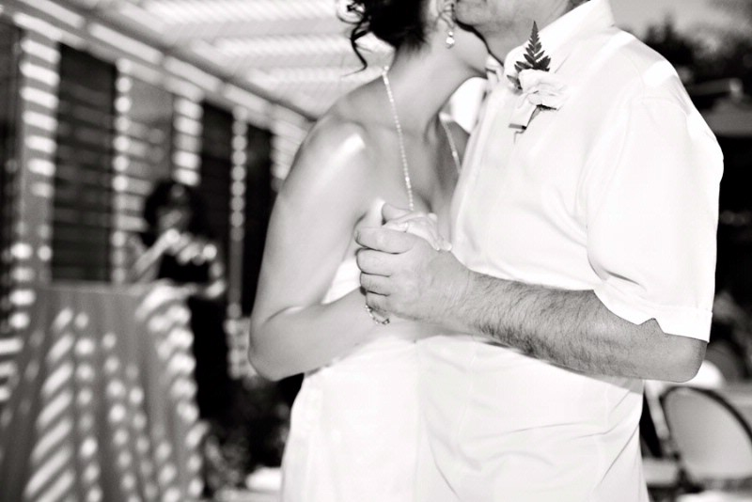
Don’t Cry For Me
My little Girl, Don't cry for me
I'll be right by your side.
I'd never miss out on this day
that you become a bride.
I'm here with you to hold your hand
and give your heart away
To a man God chose to take care of you
forever from this day.
Today, I place your hand in his
with blessings and with pride.
My little Girl, Don't cry for me
I'll be right by your side.

With Love from Dad...

I have many precious memories
since the time that you were small,
each year has held such wonder
and I've loved you through them all.

I remember when your first steps
filled my eyes with pride,
but the time has passed so quickly...
now soon you'll be a bride.

This hanky is a gift for you
that's from my heart to yours,
and with it all my blessings
as you open your life's doors.

Perhaps someday in years to come
you'll pass this hanky on...
to a loved and cherished daughter
or the bride of your grown son...

And I ask you please, to tell her of
the love that we two knew,
and that this love includes my wish
that all her dreams come true.

So many precious memories
since the time that you were small,
and now I add your wedding day
as most precious of them all.

Precious Memories

I have many precious memories
since the time that you were small,
each year has held such wonder
and I've loved you through them all.

I remember when your first steps
filled my eyes with pride,
but the time has passed so quickly...
now soon you'll be a bride.

This hanky is a gift for you
that's from my heart to yours,
and with it all my blessings
as you open your life's doors.

Perhaps someday in years to come
you'll pass this hanky on...
to a loved and cherished daughter
or the bride of your grown son...

And I ask you please, to tell her of
the love that we two knew,
and that this love includes my wish
that all her dreams come true.

So many precious memories
since the time that you were small,
and now I add your wedding day
as most precious of them all.

I wish you love and joy in your life ahead.

A Day Born Of Hope
Walking with the stars
a day born of hope
a day of never ending dreams.

A dream built on happiness
and the promise of love eternal.
Nervousness and sweaty palms.

Love eternal till death we part.
Dreams of white picket fences and
smiling children.

White gowns with long trains.
Matching rings and the vows made as daddy walks you down the aisle.
Love resonates through tears and smiles.
All faces aglow with you the picture of perfection and that of an angel.

Vows made in love and hope.
The promise of a future.
Steps to be taken. Parties to attend.

The future holds no bounds on love
that can't be contained.
Two lives joined and souls forever mingled. Lives now made one.
The days just begin.
A future to be made on this day.

A dream made the day you were born.
Daddy's dream of your happiness is now here.
A day of hope on this the day of your birth.

Don’t Cry For Me
My little Girl, Don't cry for me
I'll be right by your side.
I'd never miss out on this day
that you become a bride.

I'm here with you to hold your hand
and give your heart away
To a man God chose to take care of you
forever from this day.

Today, I place your hand in his
with blessings and with pride.
My little Girl, Don't cry for me
I'll be right by your side.

For My Stepdaughter

As your wedding day approaches
it seems not long ago
that you were just a little girl
who kept my heart aglow.

I want so much to thank you
for the times you’ve shared with me,
and all the precious memories
since I joined your family.

Sometimes things weren’t easy
when you and I first met,
but the years have proved
to both of us
there’s nothing to regret.

Now you’re getting married
a new life is soon in store,
and my prayers are always with you
as you open these new doors.

Thank you for the years we've had
there's many more we'll spend,
for yes, you are my daughter,
and you’ll always be my friend.

I wish you love and happiness
in your new life.

For My Daughter

Long ago when you were small
a baby just brand new,
I'd think about your life ahead
and paths you might pursue.

I thought I would protect you
from all the world held dear,
but you had other things in mind,
this was very clear.

For you had roads to travel
that I had not explored,
you had doors to open
I'd never seen before.

The future brings your wedding day
and as you walk the aisle,
I'll see you there... my little girl
and smile a special smile…

A smile that holds the memory of
a baby just brand new,
and all the paths you'll travel now
to make your dreams come true.

I wish you love and joy in your
exciting life ahead.

