Funny Wedding Poems
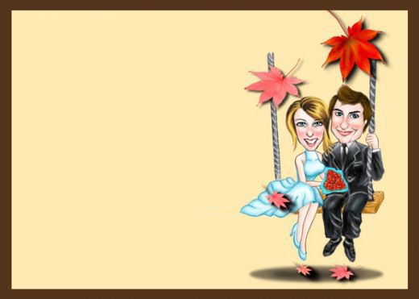
Say Goodbye, Say Hello
Say goodbye to bachelor days,
Say goodbye to freestyle ways,
Say goodbye to single life,
Say hello to your new wife!
Put your laundry in the pile,
Talk of feelings for a while,
Please wipe off the kitchen sink,
Watch your wallet start to shrink.
But say hello to love that's true,
To someone putting up with you.
She'll love you forever more,
That's more than you could ask her for!

The Wedding
Bridal gown is white and poofy.
Cousin-groomsman acts so goofy,
Sticks his finger in his nose,
Steps on sister Mary’s toes.
Grampa makes my Auntie cry.
No one knows the reason why.
Brother eats the un-cut cake,
Grabs a handful by mistake.
Gramma says the room’s too cold.
Auntie says the chicken’s old.
Uncle Charlie quaffs some ale.
Auntie says the rolls are stale.
Flowers add that special touch.
Uncle Charlie drinks too much.
Looking for a new romance
Ask’s a flowerpot to dance.
Even though it’s kind of sappy
Bride and groom both look so happy.
After all is said and done,
Weddings are such crazy fun!

Escape
Why oh why didn’t we elope?
Or marry atop a lofty ski slope?
Anywhere we could escape,
all of our family’s red tape.
I don’t care about the darn flowers.
Your mother does, she’s been here for hours.
She and my mother just can’t agree,
on two in each vase or three.
Don’t get me started on the guest list.
So many invited, we’re unlikely to be missed.
I beg you again, let’s just slip away,
and leave them to this overblown soiree.

Bouquet
After the bouquet is thrown,
Get out of the danger zone,
Women will be going wild,
All of them just so beguiled.
They'll shove and pull and also fight,
They'll keep that bouquet in their sights,
They'll scratch and push with greatest force,
(And all while smiling, of course).
All this just to be wed next,
Those who miss are truly vexed,
She who wins is full of glee,
But single men will start to flee!

Sight To See
A bride's as lovely as can be,
Her make-up painted perfectly,
Not a hair is out of place,
There is a glow upon her face.
Her gown is white and fluttery,
Her form's as shapely as can be,
Her veil surrounds her as it flows,
There's not a smudge upon her nose.
Yes, she is a sight to see,
Put together so nicely,
Then there's cake smooshed in her face,
And laughter's filling up the place!

Say Goodbye, Say Hello
Say goodbye to bachelor days,
Say goodbye to freestyle ways,
Say goodbye to single life,
Say hello to your new wife!
Put your laundry in the pile,
Talk of feelings for a while,
Please wipe off the kitchen sink,
Watch your wallet start to shrink.
But say hello to love that's true,
To someone putting up with you.
She'll love you forever more,
That's more than you could ask her for!

Drama
Here comes the bride,
please let us all go hide.
She has been a menace,
since we blacked her eye at tennis.
What did she expect?
The maid of honor she decked.
If we make it through the rehearsal,
The amazement will be universal.
An occasion to be remembered, even if our friendship dismembered.
At least the wedding cake is tasty,
even though the bridegroom’s pasty.

