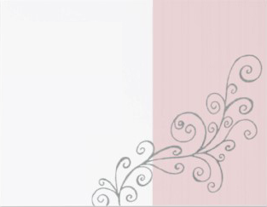
PLEASE JOIN US IN
THE
MEHENDI CEREMONY
OF
XXXX
ON FRIDAY, MARCH 19th, 2011
AT
SUBHERWAL RESIDENCE
6871 MARILYN DRIVE
HUNTINGTON BEACH, CA 92647
714.390.1711
Mehendi 1:00 pm

