Romantic Wedding Vows
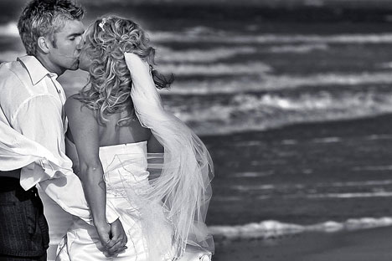
Autumn of My Life

I offer you not the “summer of my life” but the autumn, brisk and vibrant.
I promise to be a companion worthy of your precious friendship.
I pledge you compassion in good times and bad; encouragement in sickness and health.
It is my intent that our life together includes our large circle of friends and loving families.

We’ll cherish the memories of our individual pasts and create our new life as we go now together.

My Best Friend

(Name), I love you. You are my best friend. Today I give myself to you in marriage. I promise to encourage and inspire you, to laugh with you, and to comfort you in times of sorrow and struggle.

I promise to love you in good times and in bad, when life seems easy and when it seems hard, when our love is simple, and when it is an effort.

I promise to cherish you, and to always hold you in highest regard. These things I give to you today, and all the days of our lives.

Autumn of My Life

I offer you not the “summer of my life” but the autumn, brisk and vibrant.
I promise to be a companion worthy of your precious friendship.

I pledge you compassion in good times and bad; encouragement in sickness and health.
It is my intent that our life together includes our large circle of friends and loving families.

We’ll cherish the memories of our individual pasts and create our new life as we go now together.

God’s Precious Gift
You are God’s precious gift to me, my springtime, my hope and my joy.
You are everything that’s good and pure and true and I worship you with my mind, body and soul.
How blessed I am to be able to say that you are mine, to be able to love and cherish you for the rest of my days.

I vow to always put you first in my life, always be there to comfort you in your sorrow & rejoice with you in your victories.
May our hearts and very breath become one as we unite this day as husband and wife.
I promise to be your true love from this day forward and forevermore…

My One True Love

I (name), take you (name) to be my (husband/wife), my partner in life and my one true love.

I will cherish our union and love you more each day than I did the day before.

I will trust you and respect you, laugh with you and cry with you, loving you faithfully through good times and bad, regardless of the obstacles we may face together.

I give you my hand, my heart, and my love, from this day forward for as long as we both shall live.

Love You Forever
As we stand beside the ocean tide, may our love always be as constant and unchanging as these never-ending waves that pour
beneath our feet, flowing endlessly from the depths of the sea.

Your love came softly upon my heart, just as the foam comes softly upon the sand, and just as there will never be a morning without the ocean’s flow, so there will never be a day without my love for you.
I pledge myself to you this day our love will be as unchanging and dependable as the tide; as these waters nourish the earth and sustain life, may my constant devotion nourish and sustain you until the end of time.

I Promise

(Name), today I become your (husband/wife) and you become my (wife/husband). I will strive to give you the best of myself, while accepting you the way you are.

I promise to respect your interests, desires, and needs, and to realize that those are sometimes different, but no less important than my own.

I promise to keep myself open to you, to let you in to my innermost fears, feelings, secrets & dreams. I promise to grow along with you, to be willing to face change, as we change, keeping our relationship alive and exciting.

And finally, I promise to love you in good times and in bad, with all I have to give and all that I am, in the only way I know how -- completely and forever.

