Short Wedding Poems
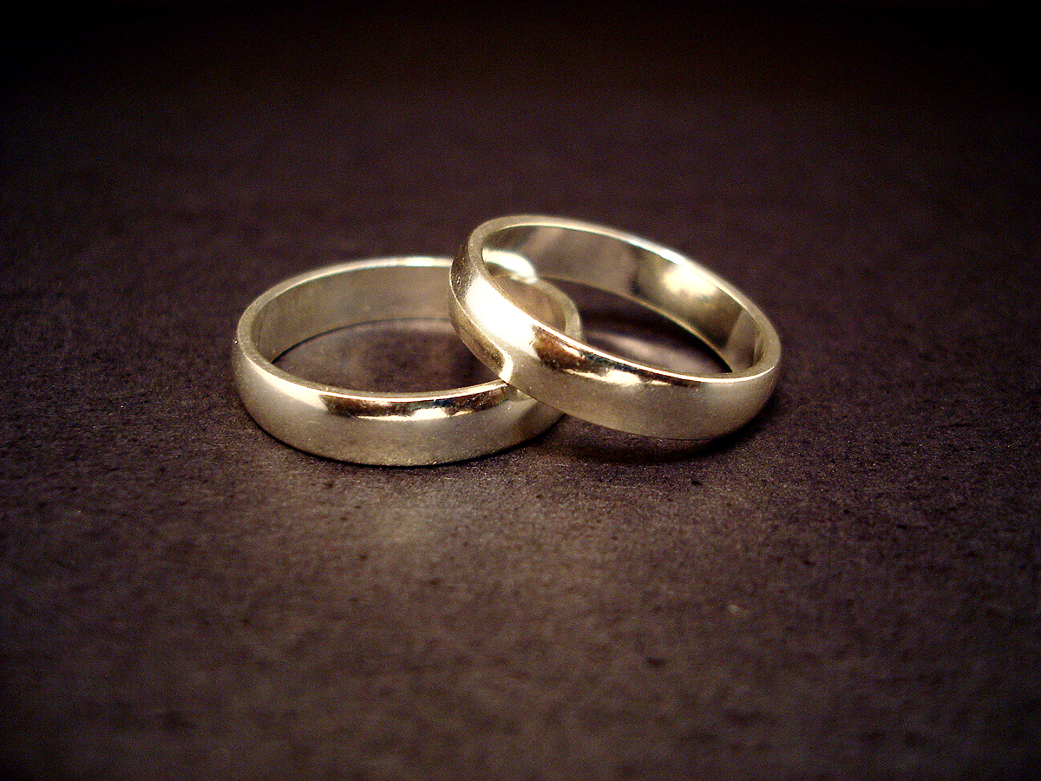
Door To Happiness

A wedding is a door to happiness,
When two decide to share their lives as one.
Your marriage is an adventure bright and new;
The pleasures and delights have just begun.

I/We wish for you a lifetime
full of love;
May you always keep that magical attraction.
Let your bond and your commitment grow with time,
So that all your days are filled with satisfaction.

Just Got Married
Throw the rice,
And clang the bells,
Listen to the shouts and yells,
There has been a wedding here,
So raise your glass and give a cheer!

Toast the groom
And toast the bride,
Now everybody to one side,
The bride will throw
The bouquet soon,
And then she's off to honeymoon.

The car is set with cans in back,
And letters written all in black,
Upon a sign that we all carried,
And it says: Just Got Married!

Door To Happiness

A wedding is a door to happiness,
When two decide to share their lives as one.
Your marriage is an adventure bright and new;
The pleasures and delights have just begun.

I/We wish for you a lifetime
full of love;
May you always keep that magical attraction.
Let your bond and your commitment grow with time,
So that all your days are filled with satisfaction.

Thank You
Today we begin the rest of our life
Together forever as husband and wife.
Our dreams came true, with love and more—
Adventures to have and the world to explore.
We’ll share our joys, we’ll share our sorrows;
We can already see many bright tomorrows.
We’ll share our friends and family, too,
And you are part of that special crew.
Thank you for celebrating our wedding day.
As we share our vows, we just want to say:
These wedding memories
Will become a treasure,
And seeing you here is part of the pleasure.

Wonderful Life
Congratulations on your marriage,
Have a wonderful life!
You are two terrific people,
Now teamed as man and wife.

A team with blessings like yours
Will live a life you'll cherish;
You’ll find happiness everywhere,
For your love will never perish.
Marriage Glow

Your wedding day is just the start
Of a lifetime full of love and fun.
It just begins as you take your vows,
When the two of you are joined as one;

We wish for you sweet happiness;
Through the years, may your love grow,
To warm you both from day to day,
In your marriage’s satisfying glow.

