Thank You Poems
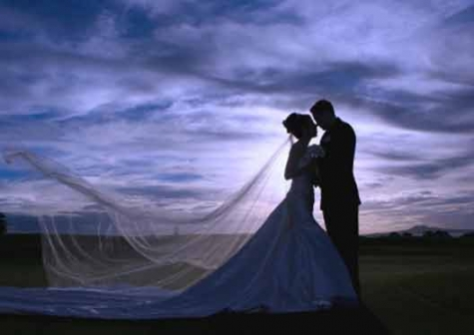
Special Thanks

Thanks for sharing,
Our wedding day,
Though we wish,
You all could stay.

We hope you go,
Happily on your way.

Our dear friends as you depart,
We hope we have done our part,
In sharing what we feel in our heart.

Thank You

How lucky we are
To have a flower girl
Who's so cute in every way.

Someone who knows
How to walk down an aisle,
& steal everyone's heart away.

So thank you for being
Our flower girl,
dropping petals to lead the way.

But thank you most of all
For helping to make ours
A perfect wedding day.

Sincerely Thank You!
We would like to thank you
In a very simple way,
For coming just to share,
Our special wedding day.
We're so glad you were there,
To celebrate our joy,
We hope that you were glad,
And the day you did enjoy.
So we sincerely thank you,
You are so dear a friend,
We simply are delighted,
That you did attend!

Together Forever

Today we begin
The rest of our life,
Together forever,
As husband and wife.

Our dreams came true,
With love and more,
Adventures to have
And the world to explore.

Thank you for celebrating
Our wedding day,
As we share our vows,
We just want to say:

These wedding memories
Will become a treasure,
And seeing you here
Is part of the pleasure.

Special Thanks

Thanks for sharing,
Our wedding day,
Though we wish,
You all could stay.

We hope you go,
Happily on your way.

Our dear friends as you depart,
We hope we have done our part,
In sharing what we feel in our heart.

Thank You Friends

We thank God
for friends like you
who support us
through and through.
Thank you for your gift
and your good cheer
and thank you for being
a friend so dear.
Sweet Thoughtfulness
Thank you very kindly,
We do not say so blindly,
For the wedding gift you sent,
Was just so sweetly meant!
We really do just love it,
So thanks for thinking of it,
You are so very kind,
And the gift is such a find.
Your thoughtfulness is sweet,
Your present was a treat,
So thank you once again,
You're such a special friend!

