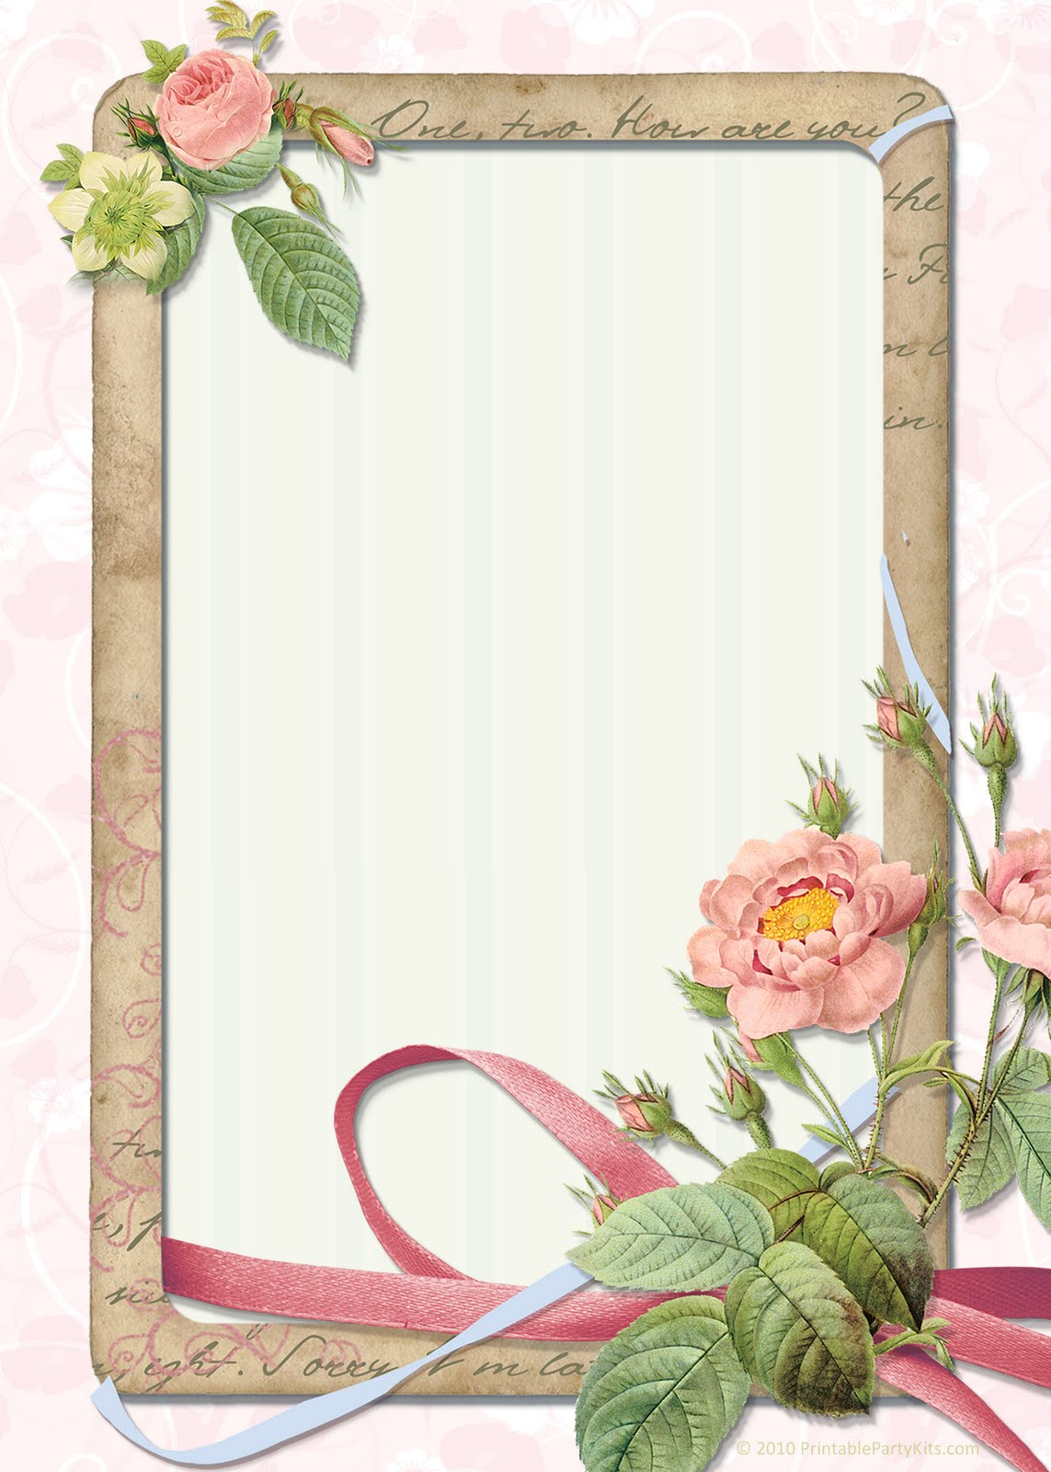
XXXX and XXXX
Cordially invite and request the company of
Festivities to be followed…
Cocktails at 5:30 P.M.
Dinner & Dance at 6:30 P.M.
At
Ballroom at the Hilton
99 Atlas Road
Woburn, Massachusetts
RSVP

